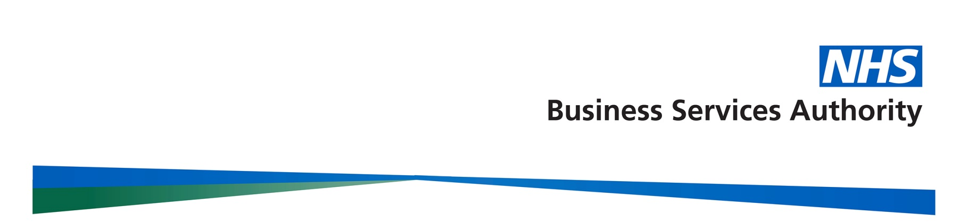
Manage Your Service Registration and Log-in Guide
Introduction
The Manage your service (MYS) portal offers an online alternative to the current paper-based processes as well as access to a range of useful services.
Pharmacy spend a lot of time processing ‘end of month’ claims and have many avenues of travel to interact with the NHSBSA in order to do so. We aim to reduce the administrative burden and avenues of travel by providing one portal for pharmacies to use to interact with us in relation to reimbursement and remuneration for services. We’ve made steps towards this by making the following available via the MYS portal:
- pharmacy prescription batch submission forms
- referred back and disallowed items
- Pharmacy Quality Scheme (formerly Quality Payment Scheme)
- prescription image request
Pharmacies can also request information reports providing more visibility of claims made.
You can log-in to your MYS account using your smartcard or with your personal NHSmail credentials should use of smartcard not be suitable for your pharmacy or staff.
This document provides guidance on registering for an MYS account and how to log-in to the MYS portal. The NHSBSA would advise reading this guidance in full, prior to starting your registration and using the MYS portal.
Setting up your account via NHSmail
In order to set-up your account, a business owner/director or verified user of the NHSBSA Information Services Portal must have completed the Manage Your Service Access Authorisation Form providing details of the individuals they wish to be registered, which pharmacy or pharmacies they require access to and whether they require pharmacy level access or management level access right. Users will be set up as a pharmacy user by default unless it is stated specifically that a user is to be given management level access.
Once users have been enabled by NHSBSA, each individual will receive an email to their personal NHSmail address from Microsoft Invitations (invites@microsoft.com) on behalf of MYS Registrations; click get started within the email to start the individual set-up process.
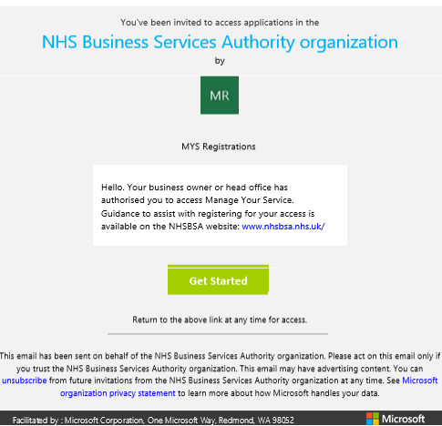

NOTE: Screenshot is for demonstration purposes only and may vary.
It is possible that this email will go into your junk mail so please check there periodically before calling NHSBSA to query. NHSBSA will endeavour to send invitations out within 2 working days upon receipt of the user access authorisation form; however this may take longer. We would ask that you wait up to 5 working days before raising any calls with the Manage Your Service admin team at nhsbsa.mys@nhs.net.
You may be presented with the NHSmail log-in screen at this time. If so, enter your personal NHSmail address and password.

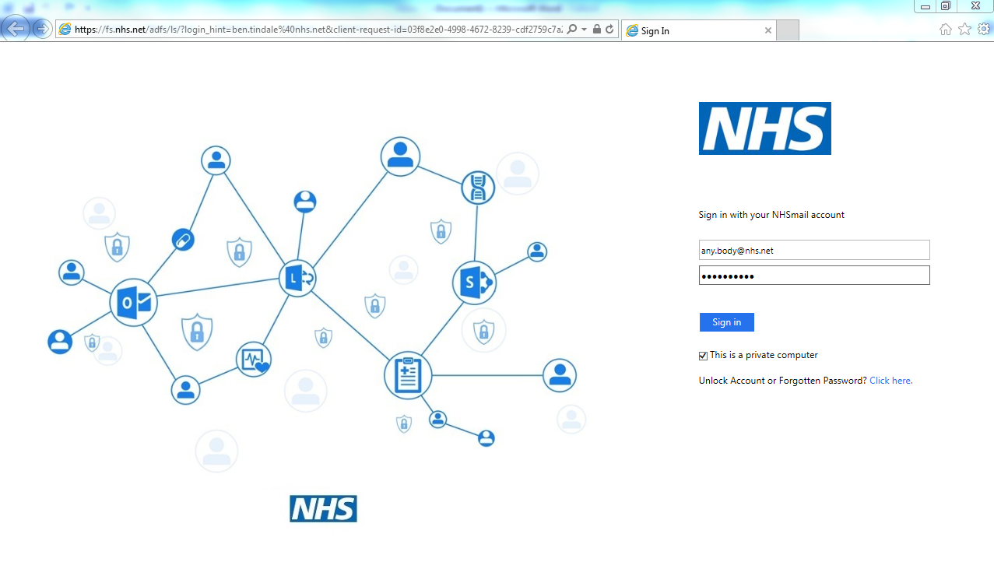
NOTE: This screen may not appear if you are already logged into NHSmail.

Once you have successfully logged-in to your NHSmail account, you will be presented with the following screen. We would advise you click No at this stage.
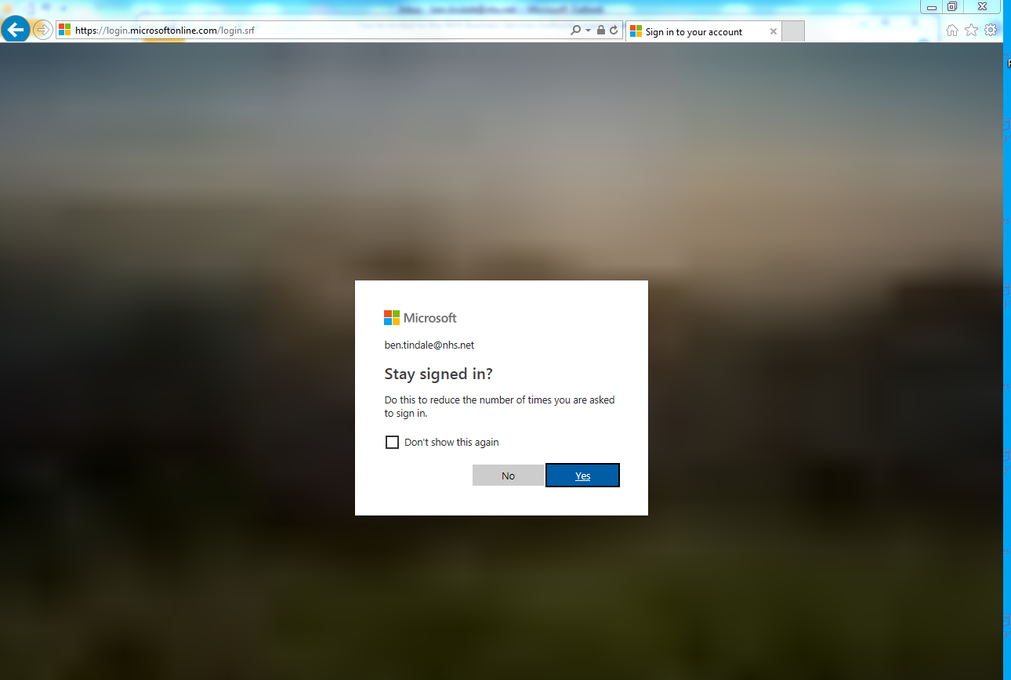

You may then be presented with the ‘Apps’ screen below. Left click on the MYS icon to proceed to the MYS application.

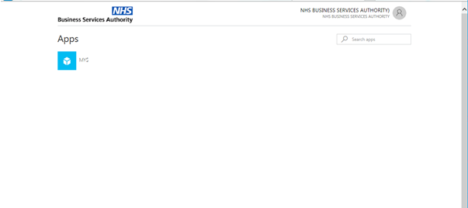
You will then be presented with the Manage Your Service sign-in screen. At this stage you can choose whether to sign in with a smartcard or NHSmail credentials.

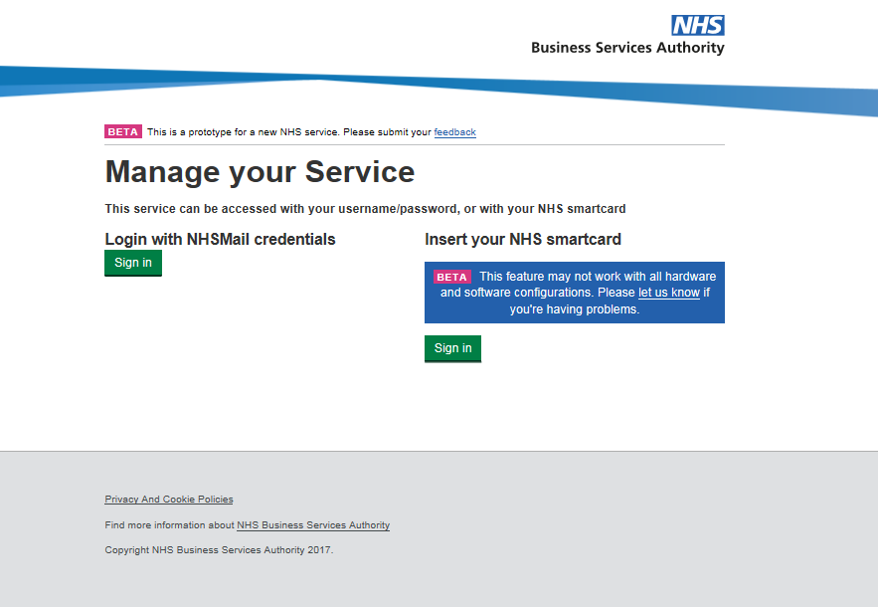

NOTE: As stated on the screen, smartcard access may not work dependent on your hardware or software configurations. Further information on smartcard access can be found in the FAQs at the end of this guide.

If logging in with NHSmail credentials, click the sign in option on the left hand side of the screen.

The NHSBSA would advise that you save this page to your favourites or add a shortcut to your desktop for ease of future access. The web page address to save is:
https://services.nhsbsa.nhs.uk/nhs-prescription-services-submissions/login

Single Pharmacy Access
If you have been set up with access to one pharmacy only, you will be presented with the Manage Your Service Dashboard screen for that pharmacy, once you have successfully entered your credentials.
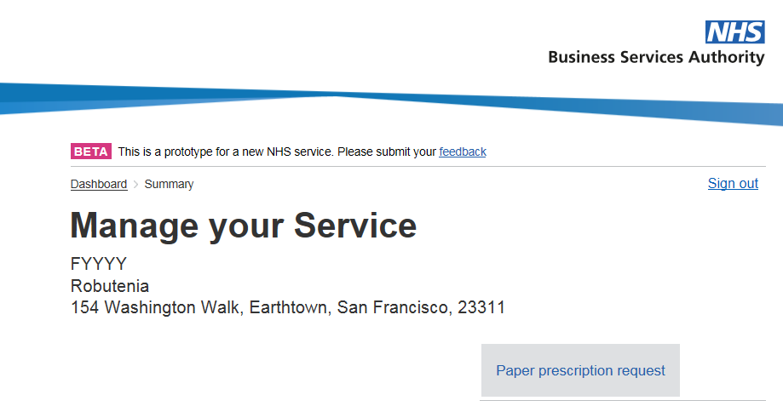
NOTE: Screen displayed is for demonstration purposes only; the screen you see may vary.
Multiple Pharmacy Access
If you have been set up with access to multiple pharmacies, you will be presented with the option to enter ODS/’F Code’ of the pharmacy you wish to access once you have successfully entered your credentials. If your pharmacies have previously been set up with a YP code, you can also access the portal with this code to see a group of pharmacies.
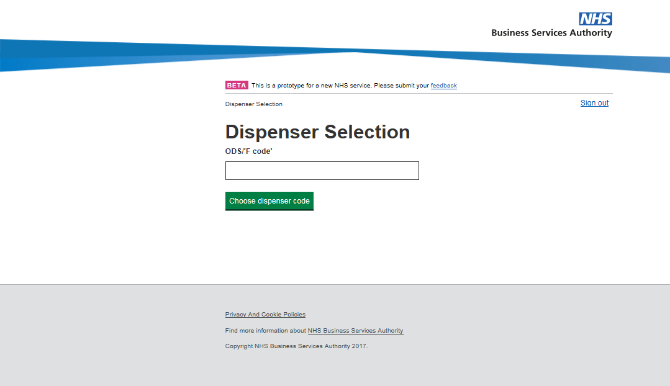
Adding New Users
Once you have completed your initial registration and list of users, anyone with delegated management level access will be able to add additional users via their access to the portal for pharmacies they have been given access to.
To do this, click Manage Users from the dashboard screen.
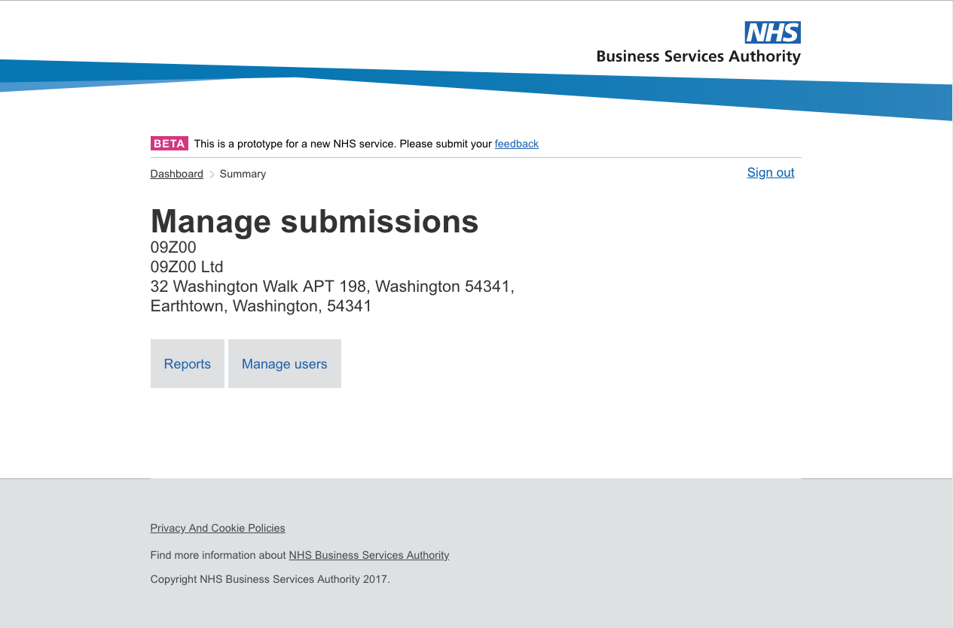
NOTE: Screenshot is for demonstration purposes and may vary.
You will be presented with a list of users currently assigned to the pharmacy or pharmacies you have access to. Click ‘Create a new user’.
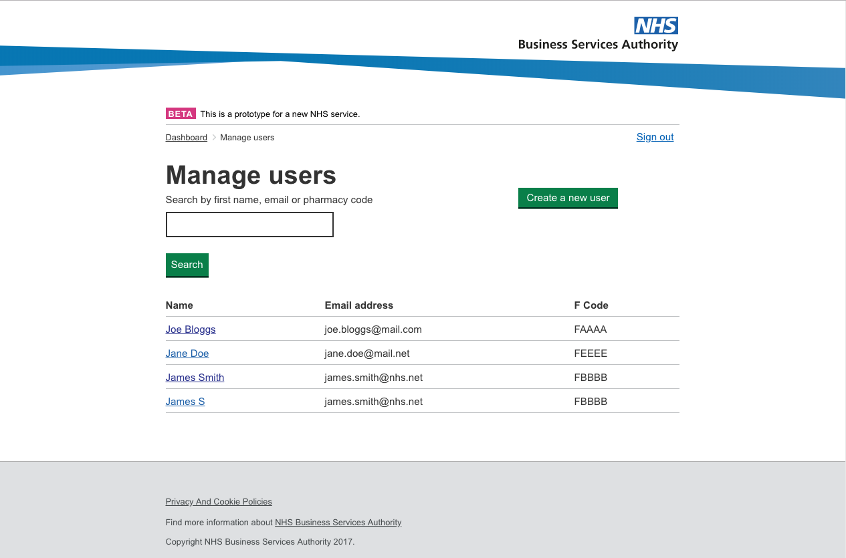
Enter the new users Full Name, personal NHSmail address of the individual and the ODS/’Fcode’ of the pharmacy they are to be given access to. You will also be required to select whether they have pharmacy permissions or management permissions. Then click ‘Create user’.
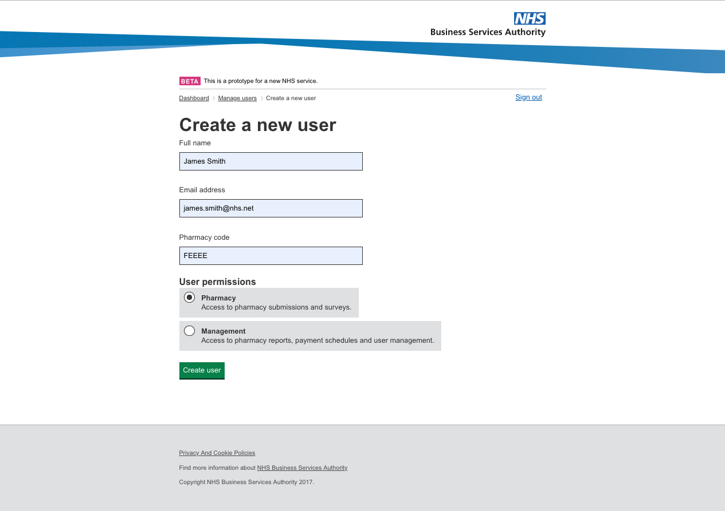
NOTE: You will only be able to provide an ODS/’Fcode’ that you have access to yourself.
Clicking ‘Create user’ will send the information of the new user to NHSBSA who will then create the user account. Accounts are usually created within 48 hours but we ask that users wait 5 working days before contacting NHSBSA to enquire into the progress of the account being created if they haven’t received their invitation email
Removing Users
Once you have completed your initial registration and list of users, anyone with delegated management information access will be able to remove users via their access to the portal for pharmacies they have been given access to.
To do this, click Manage Users from the dashboard screen.
Click ‘Manage Users’. You will be presented with a list of users currently assigned to the pharmacy or pharmacies you have access to. Click the user you wish to remove.
Once you have selected the user, click ‘Delete user’
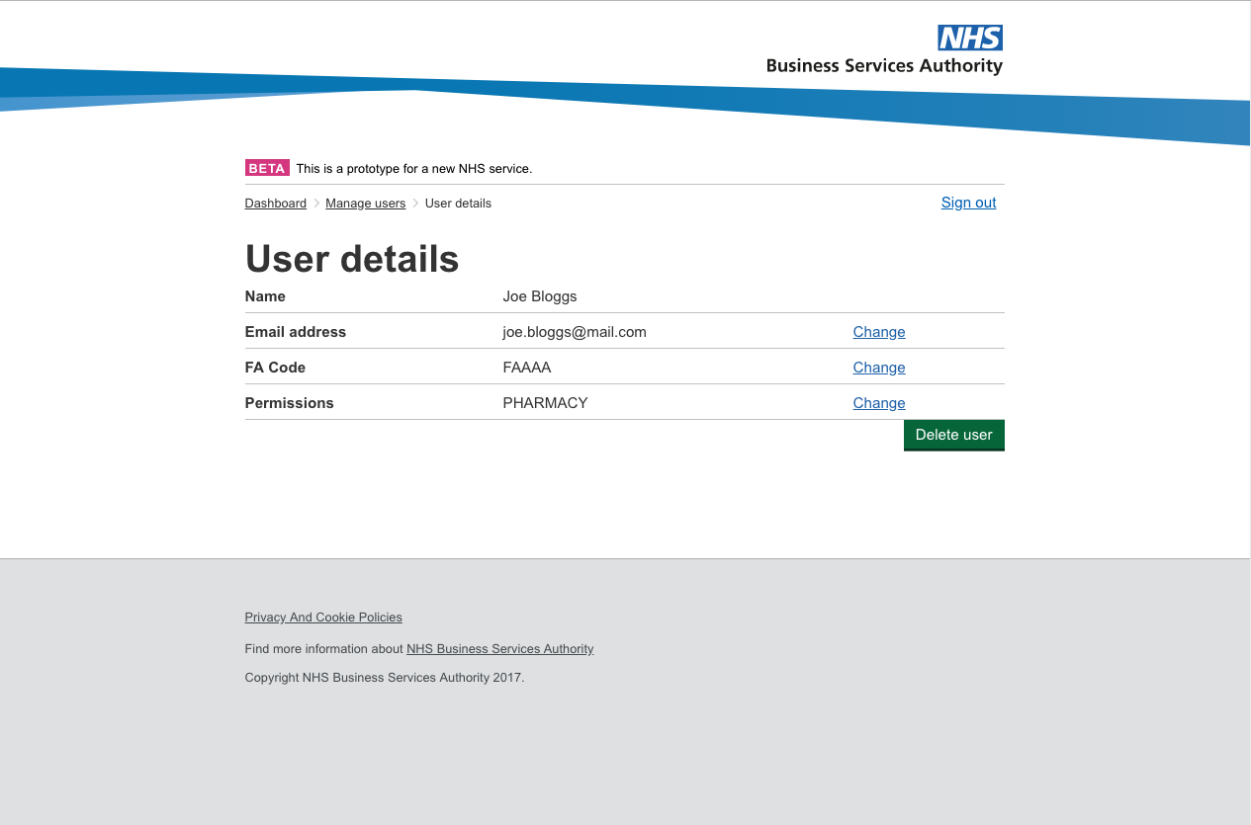
To confirm you wish to remove the user, click ‘Yes, remove user’.
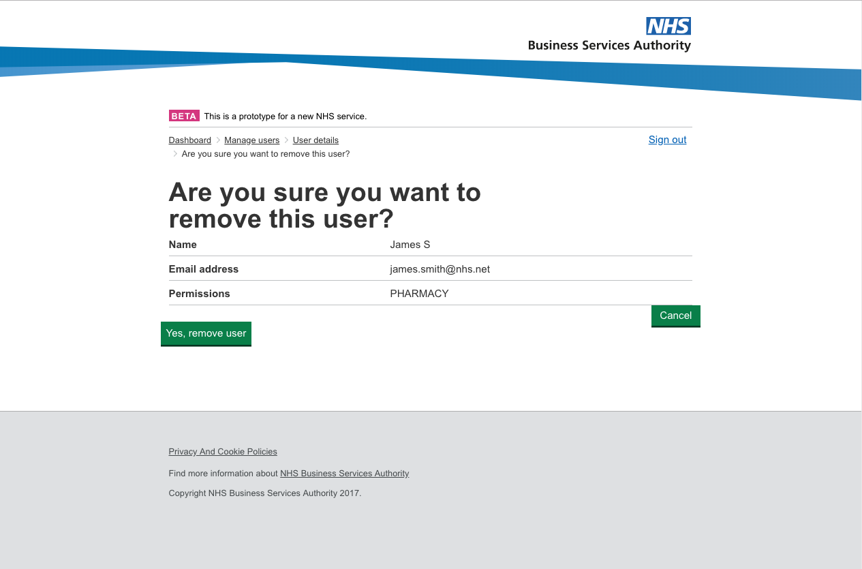
Clicking ‘Yes, remove user’ will send the information of the user to NHSBSA who will then remove the user account. Accounts will be removed within 2 working days.

Editing User Details
Once you have completed your initial registration and list of users, anyone with delegated management information access will be able to edit a user’s details via their access to the portal for pharmacies they have been given access to.
To do this, click Manage Users from the dashboard screen.
Click ‘Manage Users’. You will be presented with a list of users currently assigned to the pharmacy or pharmacies you have access to. Click the user you wish to edit.
To edit details, click the ‘Change’ button of the field you wish you edit.
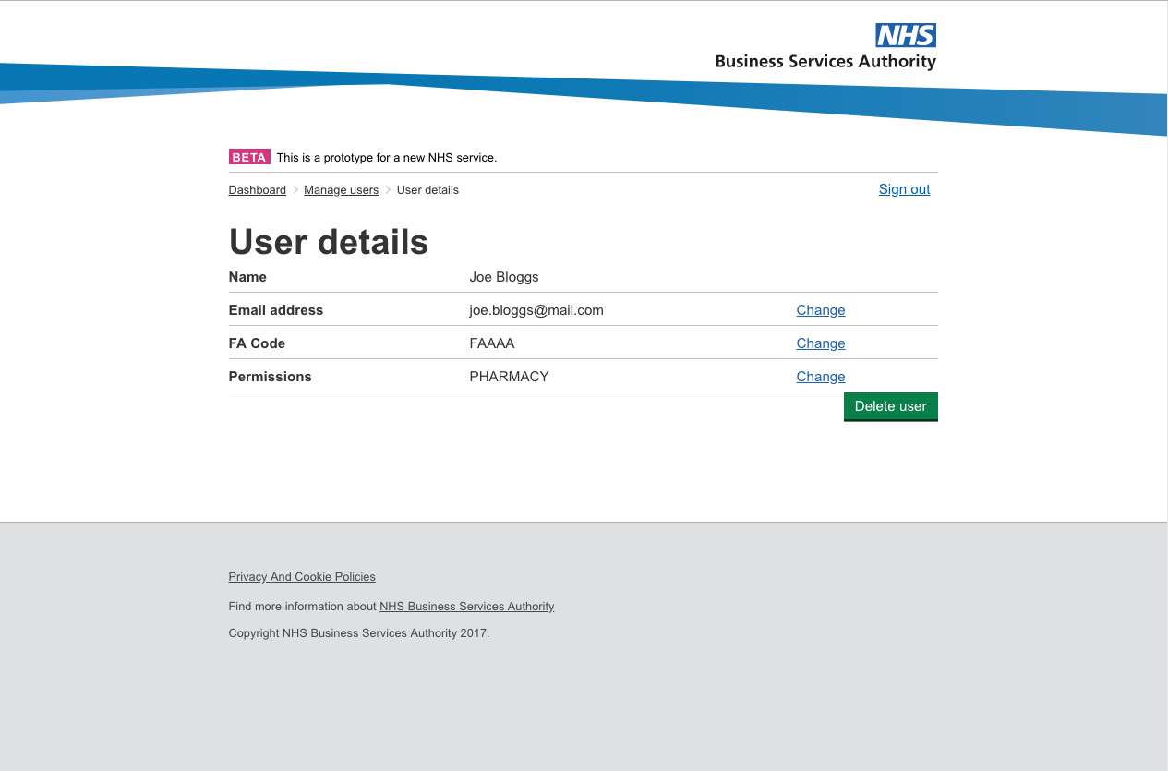
Once you have provided the updated information, click ‘Update’.
NOTE: If changing the pharmacy the user has access to, you will only be able to change this to a pharmacy you have access to yourself.
Name and email address changes cannot be done via MYS; these must be handled by NHS Digital which will subsequently update the MYS record in due course.
FAQs
I don’t have a scanner available in my pharmacy to be able to sign the form and email it back to you, what should I do?
We appreciate not all pharmacies will have access to a scanner. In these instances you can post your completed form to us at:
Manage Your Service Registrations
2nd Floor
Bridge House
152 Pilgrim Street
Newcastle
NE1 6SN

Or contact the MYS Helpdesk at nhsbsa.mys@nhs.net to discuss other alternatives if available.

Why do I have to provide a wet signature on my authorisation form?

As we’re potentially giving MYS users access to business sensitive data and patient identifiable data, we need to be assured that we’re receiving the initial authorisation form from appropriate individuals. Therefore, we require a handwritten signature to meet our stipulated audit requirements.

Does the form need to be typed or can it be handwritten?
It is preferable for the form to be completed using Microsoft Word (typed) as if we need to contact contractors to clarify handwritten information, this may cause a delay in the registration process. However, if this is not possible, the form can be completed in full by hand. Contractors are advised to use block capital letters if doing so.

What do I need to sign in with my smartcard?
If you want to attempt to sign in with a smartcard, you will need the following on your PC:
  - Internet Explorer version 11
  - Java plugin, version 8
  - Smartcard reader + smartcard
  - Identity Agent 2

You also need one of the following RBAC roles on your smartcard:
  - R1290 – Pharmacist OR
  - R8003 – Health Professional Access Role OR
  - R1979 – Pharmacy Technical Officer OR
  - R8008 – Admin/Clinical Support Access Role OR
  - Any role with additional activity B0572 - Manage Pharmacy Activities
If you meet this criteria and have successfully inserted your smartcard and PIN you should be presented with the MYS dashboard when you click sign in.
NOTE: If you have an older version of the Java plugin, you may see a warning like one of these: Do NOT update your Java plugin – it may impact access to other Spine services that you use
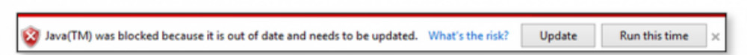
In this instance, click Run this time.
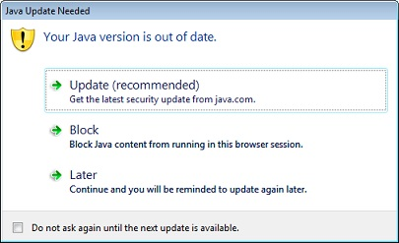
In this instance, click Later
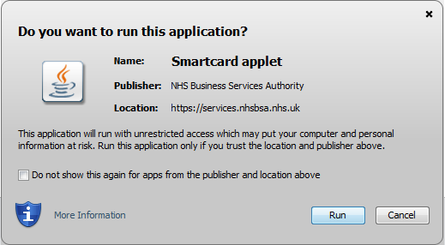
In this instance, click Run
I have everything the NHSBSA has mentioned to use my smartcard but it still isn’t working, what should I do?
If Internet Explorer is not your default browser, ensure the application is being opened with Internet Explorer. You may have to open the browser first and input the link to Manage Your Service into the search bar. The link to input is:
https://services.nhsbsa.nhs.uk/nhs-prescription-services-submissions/login
Whilst meeting the criteria above, there may be other restrictions in relation to your IT set-up which don’t allow access to our application. We would advise discussing this with your IT providers in the first instance or accessing the application using your personal NHSmail address and following the steps outlined in the guide.
How do I register extra users?
See Add New Users section of the guide. If you require any further assistance please contact us at nhsbsa.mys@nhs.net
How do I remove users?
See Remove Users section of the guide. If you require any further assistance please contact us at nhsbsa.mys@nhs.net
How do I get access to the other features of MYS in addition to the PQS declaration?
If you’re interested in using the other features MYS has to offer, please email nhsbsa.mys@nhs.net to let us know. The MYS team will be in touch to facilitate making the other features available to you.

